Python Internship Report

Personal details
Name : Amisha Patel
Collage Name : Swarrnim Start-up and innovation university
Degree : B.E
Sem : 8
Github URL :https://github.com/Amisha4/new-project

Company Detalis
Comapany Nmae : Akash technolabs
External Guide : Akash padhiyar
Traininig Duration : 26-5-2021 to 21-6-2021

Practical : 1

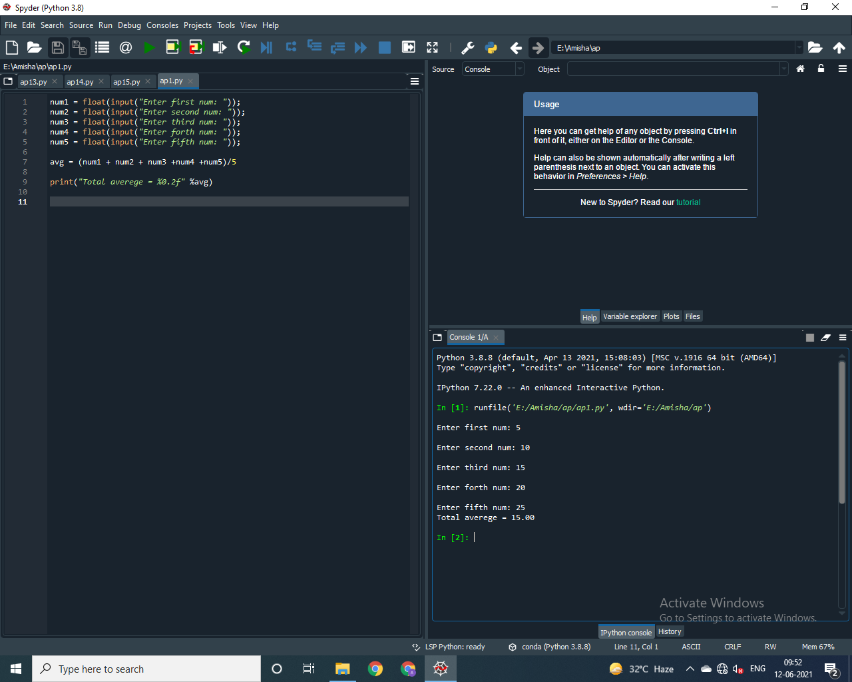

Practical : 2

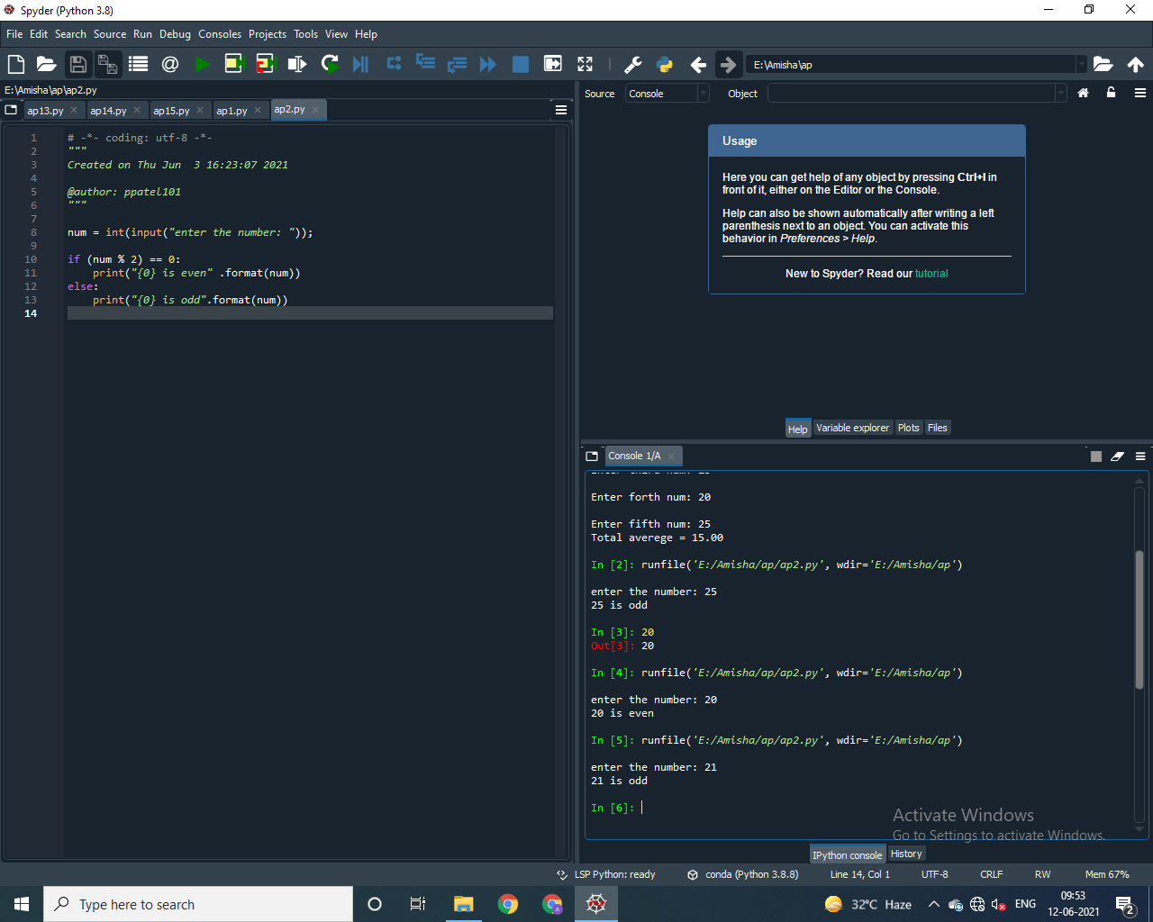

Practical : 3

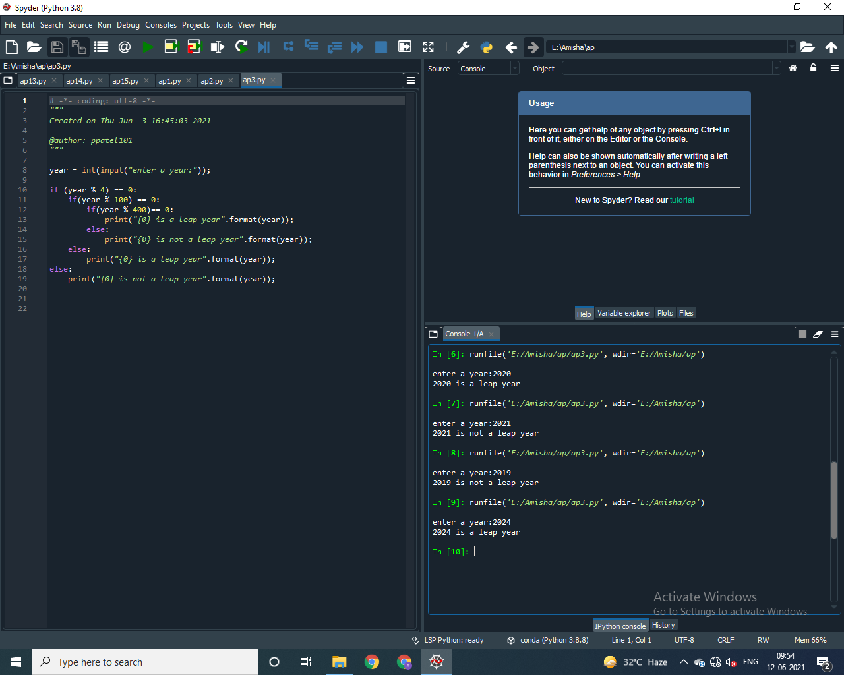

Practical : 4

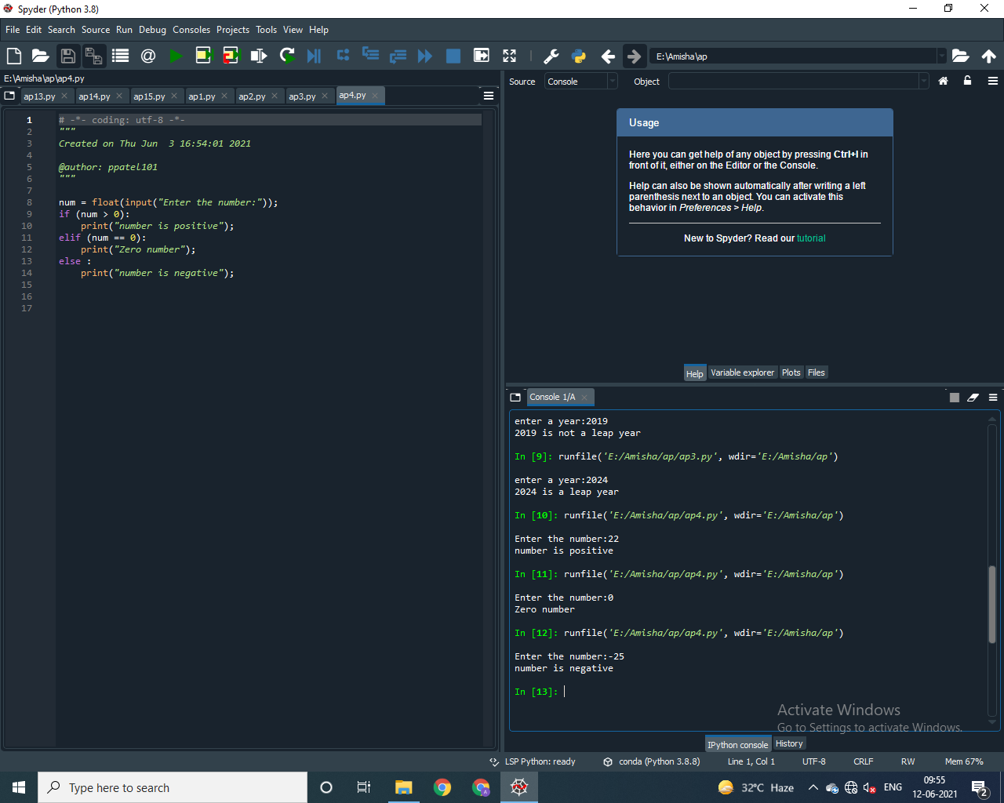

Practical : 5

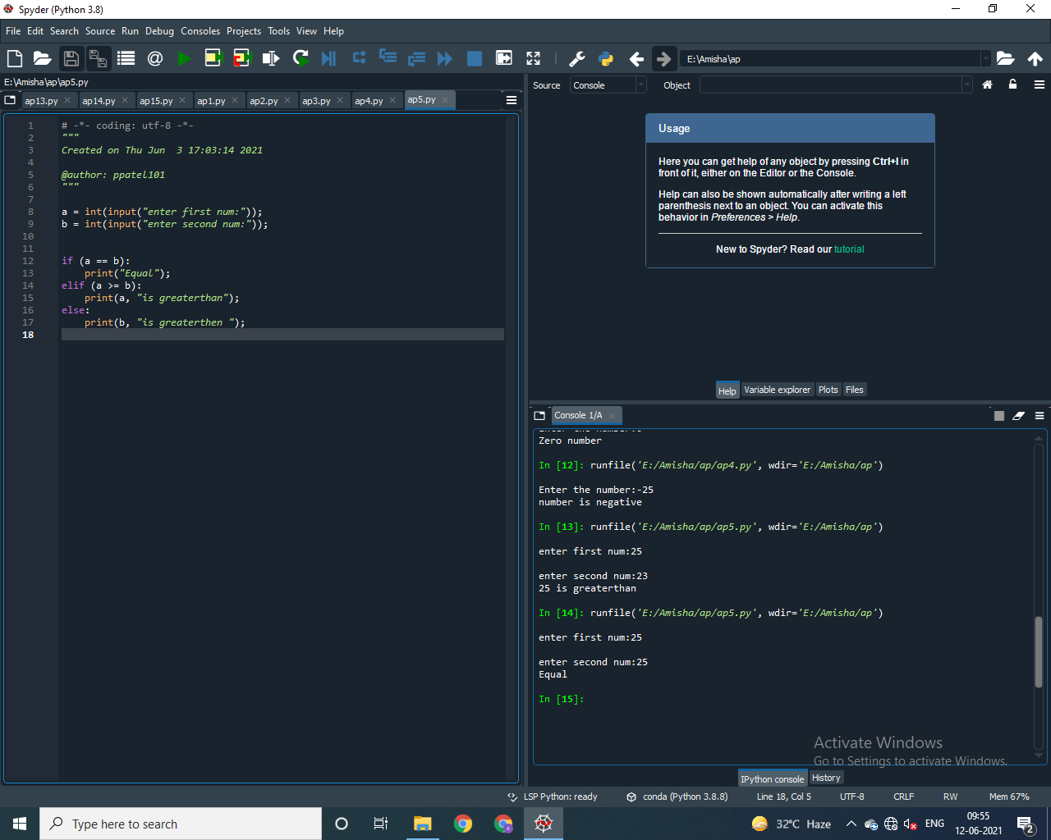

Practical : 6

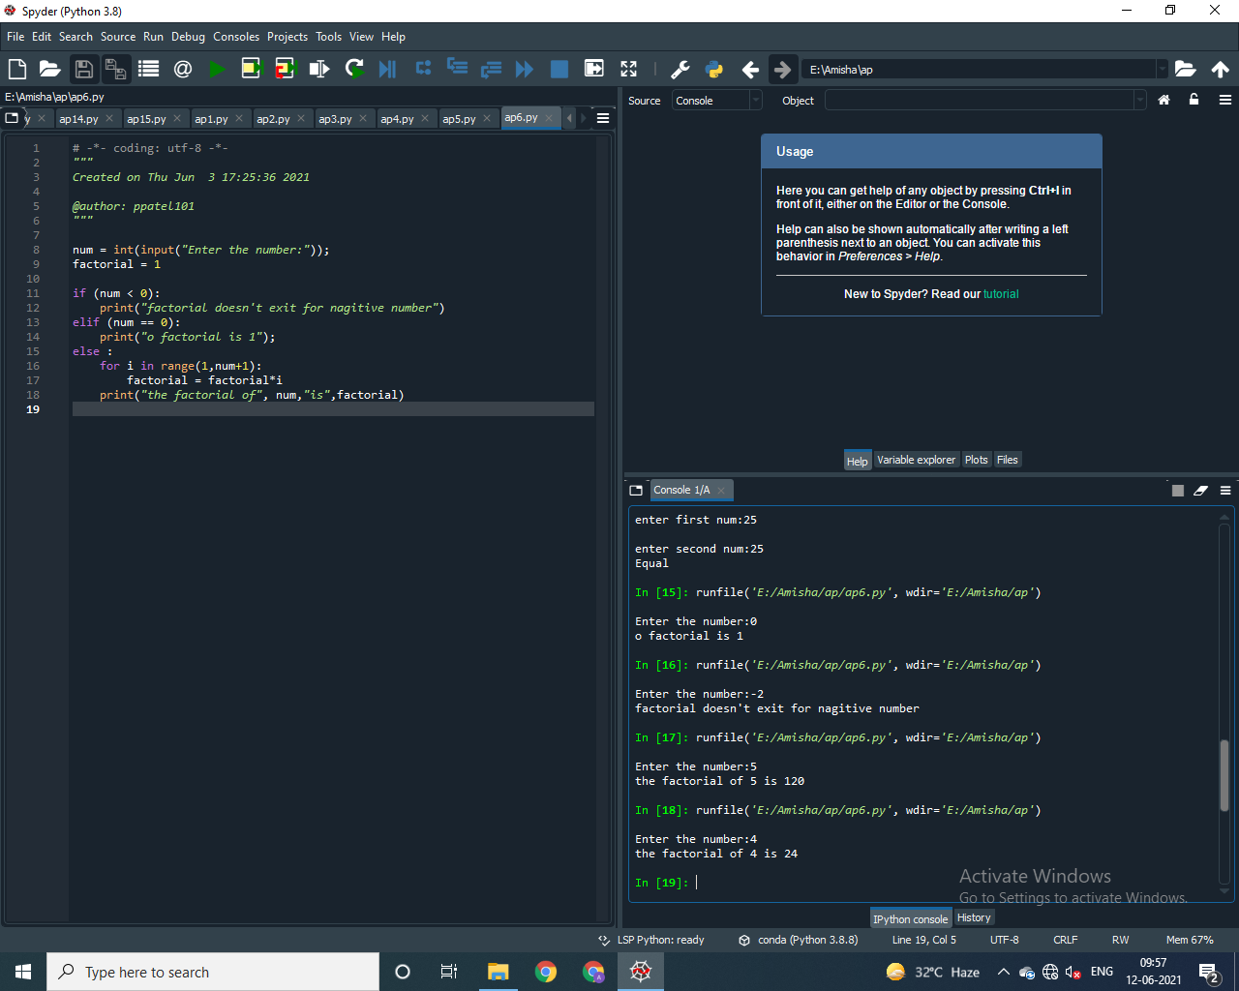

Practical : 7

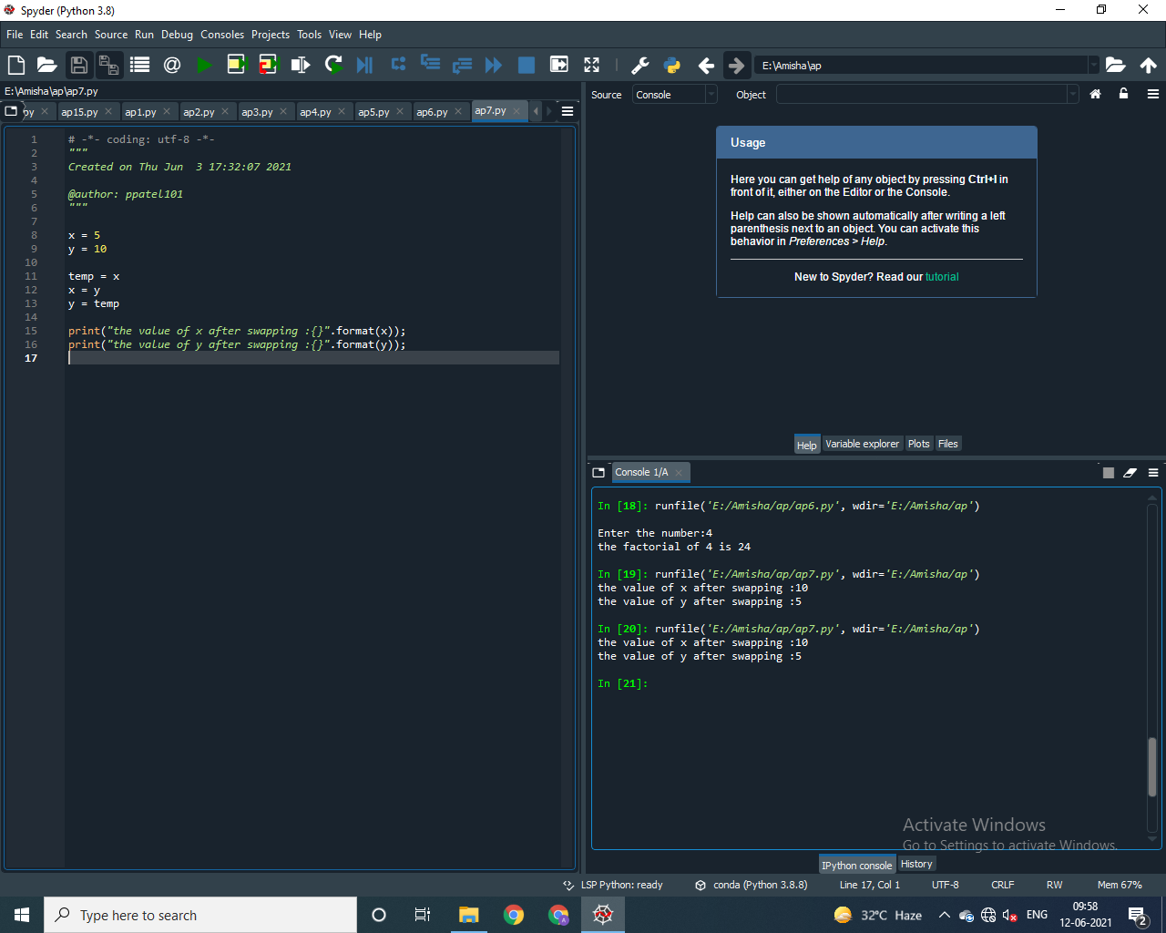

Practical : 8

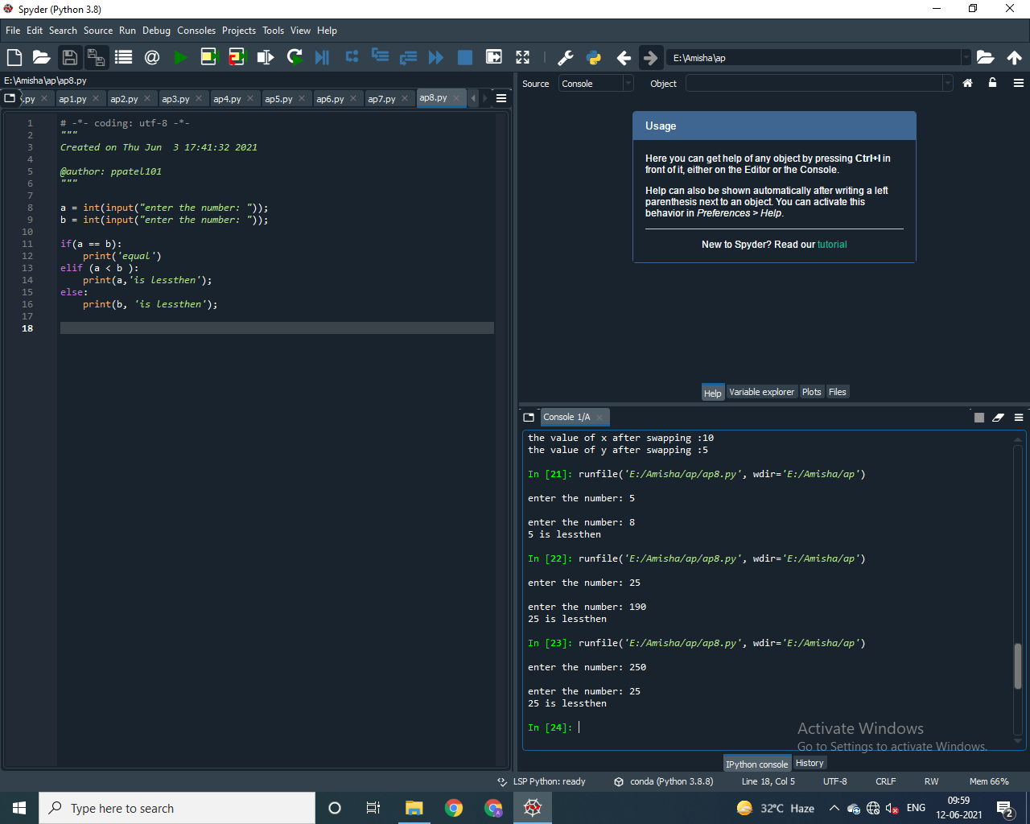

Practical : 9

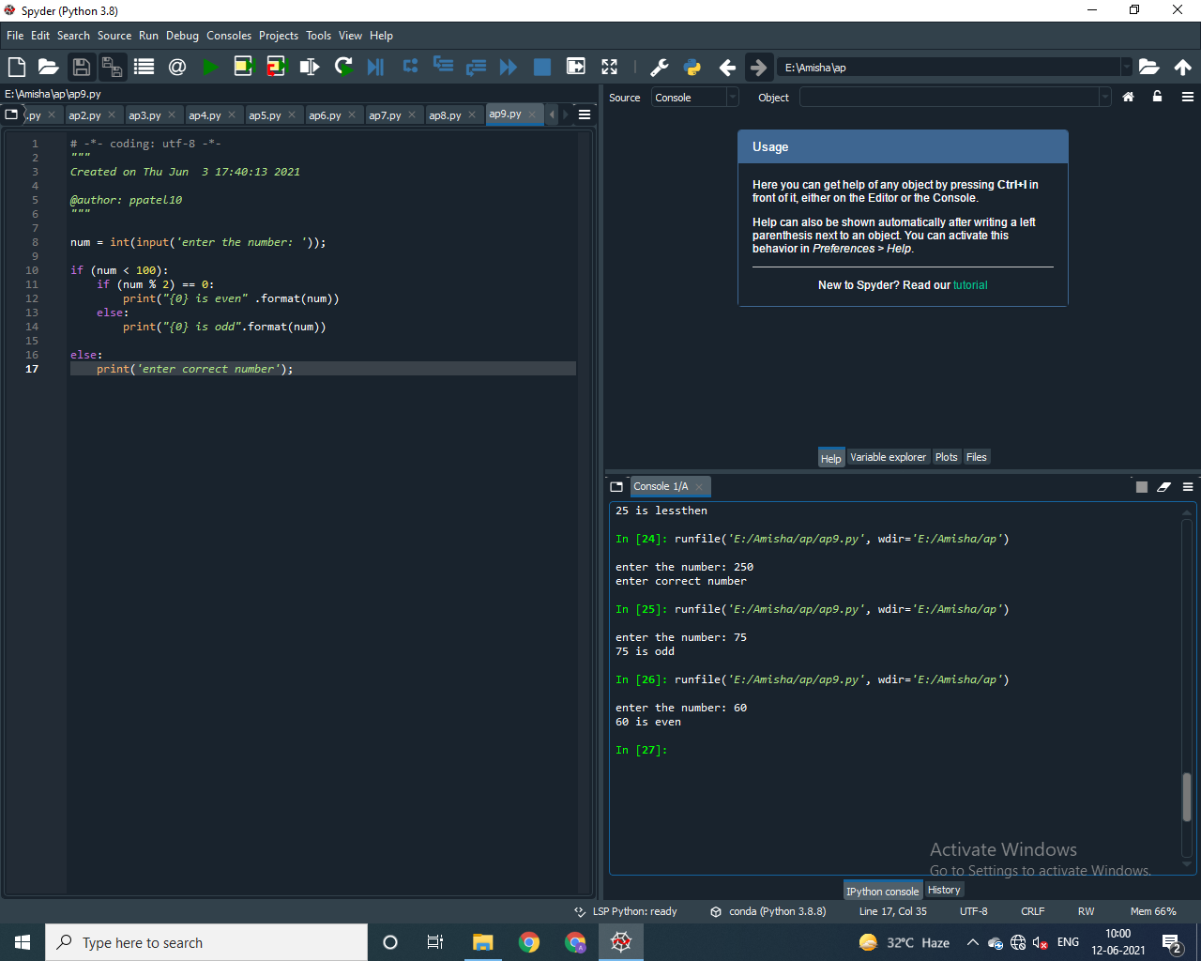

Practical : 10

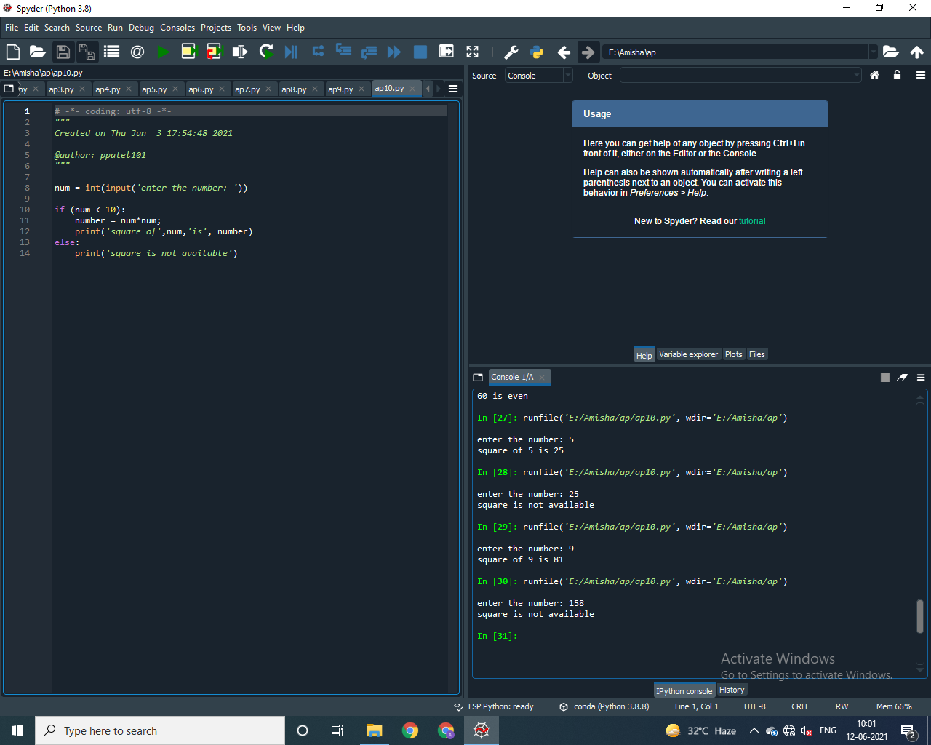

Practical : 11

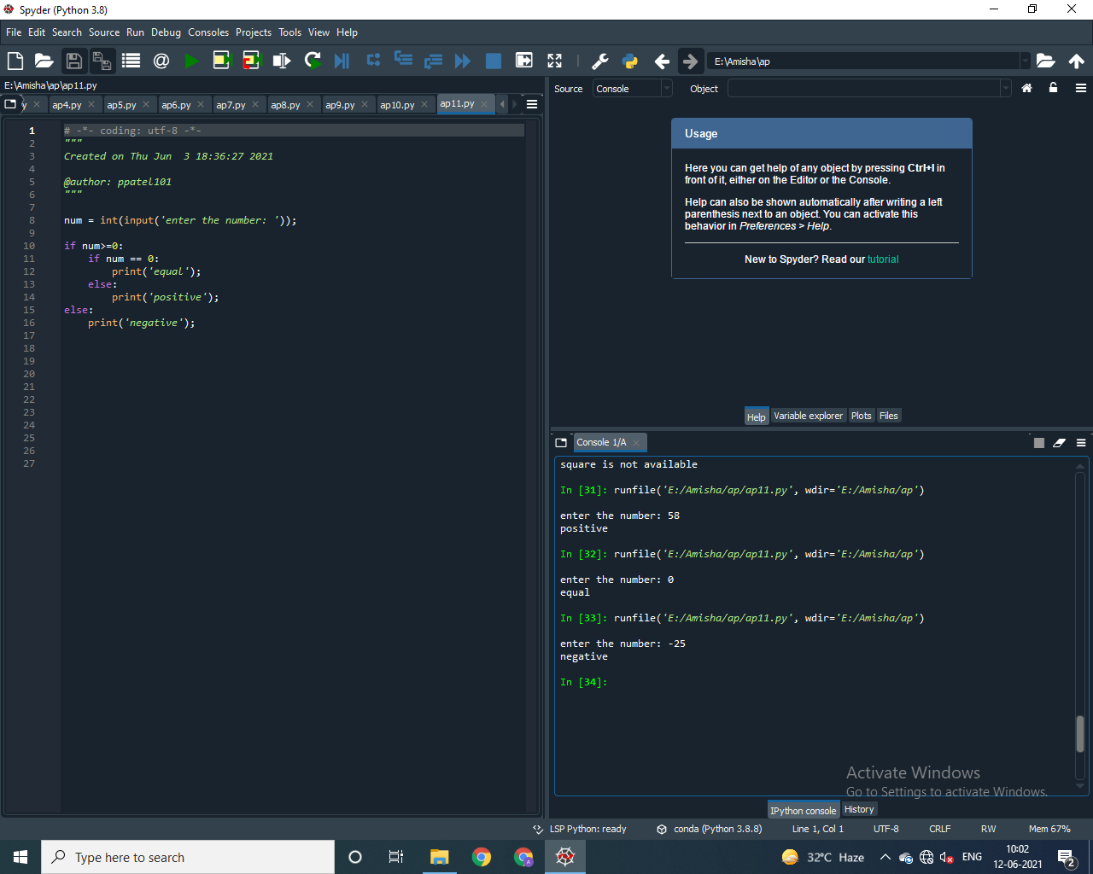

Practical : 12

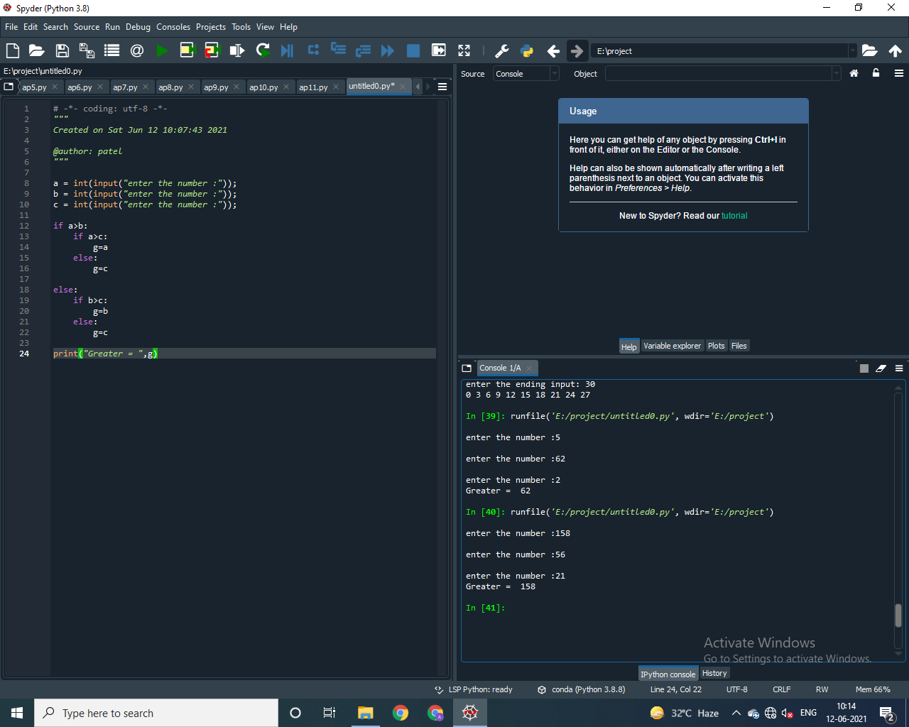

Practical : 13

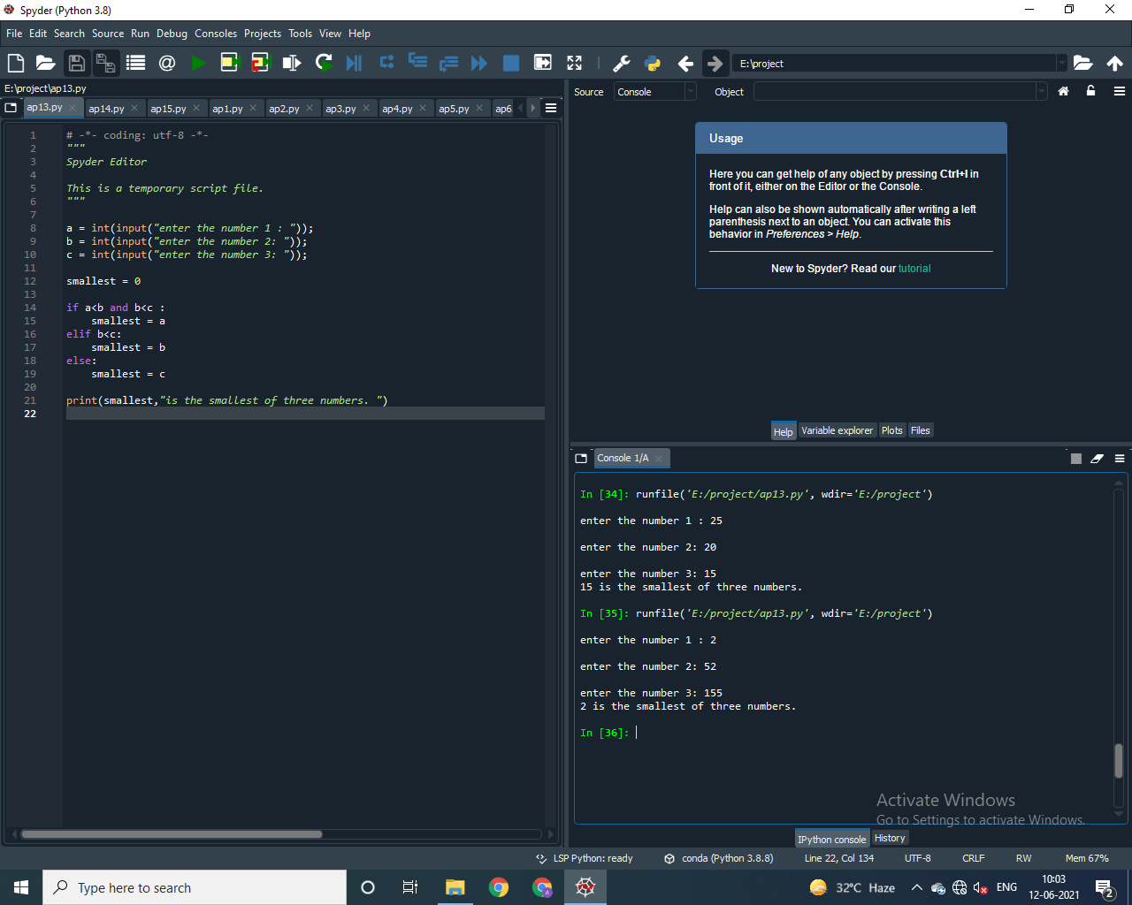

Practical : 14

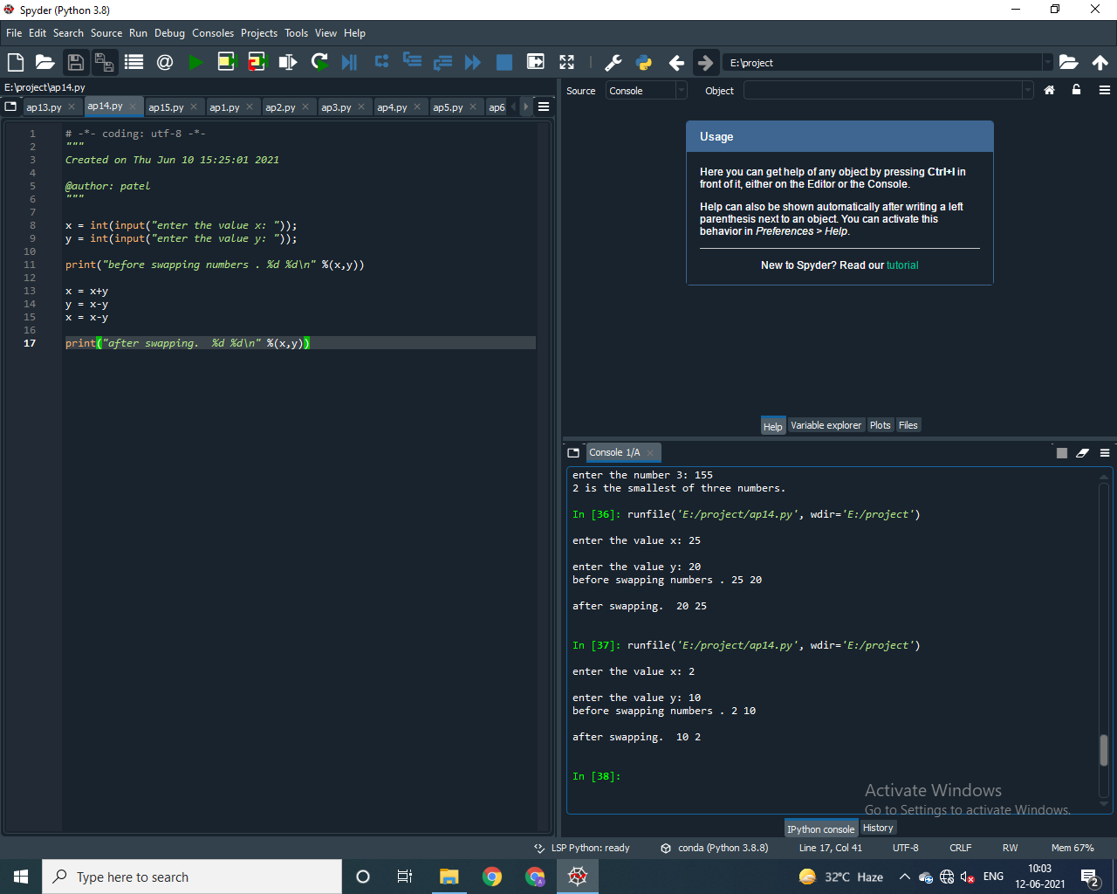

Practical : 15

